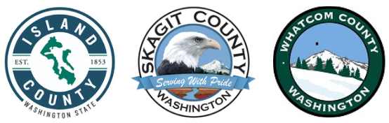
Skagit County HOME Consortium
TBRA Renewal Funding Application

FUNDING REQUEST
Detail below the funding requested for each of the counties in the Skagit County HOME Consortium.
Skagit County: Click or tap here to enter text.
Island County: Click or tap here to enter text.
Whatcom County: Click or tap here to enter text.
PROGRAM PLAN AND GOALS
Estimate the following based on the funding request detailed above, not including previously awarded HOME TBRA funds.
Households Served: Click or tap here to enter text.
Individuals Served: Click or tap here to enter text.
Estimated Expenditure Date of Requested Funds*: Click or tap here to enter text.

TBRA RENEWAL NARRATIVE
If you anticipate any changes to your organization’s HOME TBRA program, please describe them. If you do not anticipate changes to your program, you may skip this question: Click or tap here to enter text.

